**Fundamentals Of Programming**

**Program Proposal**

**Car Dealership Management (CDM)**

**Proposal Contents:**

Title of the System

Car Dealership Management

Description of the System

This project, which is a topic of the Fundamentals of Programming course, involves creating a car dealership management entirely in C++. We are pleased to announce the release of a convenient console application for performing management system tasks like adding new car(s) to a data set, modifying and deleting car(s) from a data set, exporting order logs, etc.

**Features**

Planned (✘) and currently working (✔) - but not necessarily fully completed - features:

**Admin**

* ✓ Edit Employee Data
  + ✓ Add Employee Data
  + ✓ Display Employee Data
  + ✓ Search Employee Data
  + ✓ Edit Employee Data
  + ✓ Delete Employee Data
* ✓ Cars Data
  + ✓ View Cars Name & Price
  + ✓ Add Cars Name & Price
  + ✘ Edit Cars Name & Price
  + ✓ Delete Cars Name & Price
  + ✓ View Cars Color
  + ✓ Add Cars Color
  + ✓ Edit Cars Color
  + ✓ Delete Cars Color
* ✓ Order Logs
  + ✓ Date
  + ✓ Time
  + ✓ Car Name
  + ✓ Car Color
  + ✓ Car Price
* ✓ Order Cars
  + ✓ Cars Name & Price
  + ✓ Cars Colors
  + ✓ Cashier
  + ✓ All logic corrected
* ✓ About Us

**Employee**

* ✓ Order Logs
  + ✓ Date
  + ✓ Time
  + ✓ Car Name
  + ✓ Car Color
  + ✓ Car Price
* ✓ Order Cars
  + ✓ Cars Name & Price
  + ✓ Cars Colors
  + ✓ Cashier
  + ✓ All logic corrected
* ✓ About Us

**Guest (Public)**

* ✓ Order Cars
  + ✓ Cars Name & Price
  + ✓ Cars Colors
  + ✓ Cashier
  + ✓ All logic corrected
* ✓ About Us

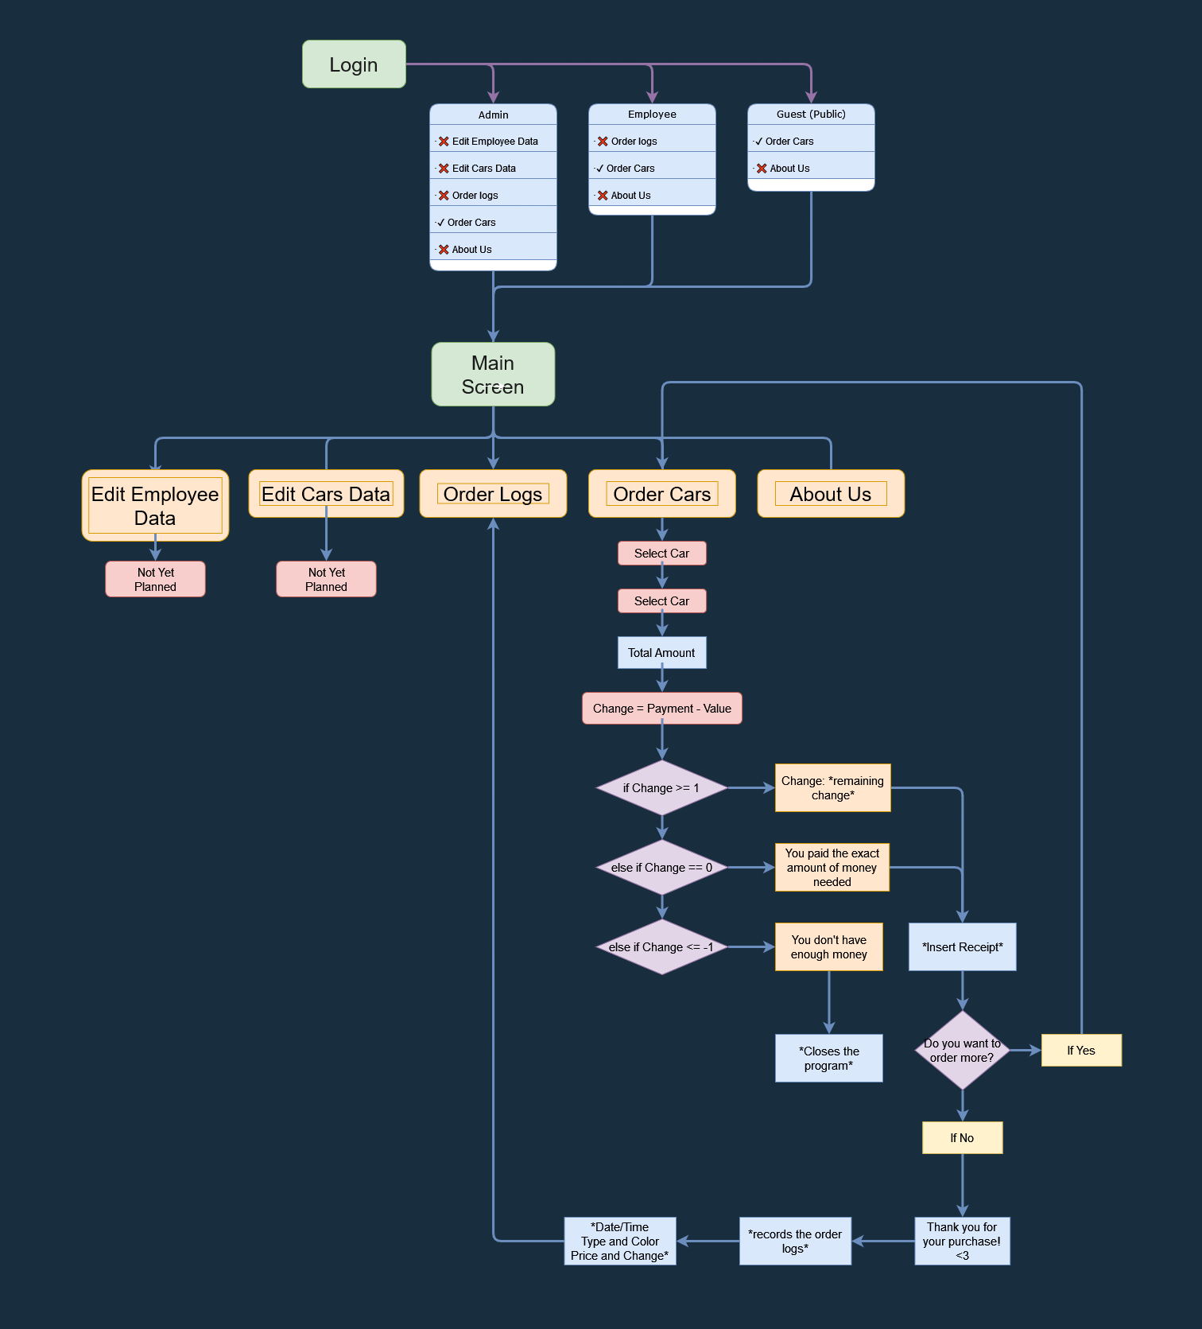

**Programming Paradigms & Principles Used**

* Object-Oriented Programming
* Procedural Programming
* Code Reusability
* File Handling

## How to Use

The user must first log in; if they do not already have an account, they can utilize the 'Guest' or public entry option. Once in the Main, all users may proceed to order Toyota cars. However, only those with admin-level access may view the order logs and edit a car's data. Administrators must answer for their conduct.

## Login Information

**Admin**

| **Username** | **Password** |
| --- | --- |
| Namias | Namias |

**Employee**

| **Username** | **Password** |
| --- | --- |
| Miku | Miku |

## How to Run

**Requirements**

* Download and Install Microsft Visual Studio 2019 or higher version.
* Download and Install MinGW driver

**Setup**

1. Clone the repository or Download and Extract the source code zip file.
2. Open the extracted file and open "CarDealership.exe"
3. That’s it.

**Limitation**

* No GUI interface
* Can only take 1 order at a time
* Can't display product images

Hierarchy

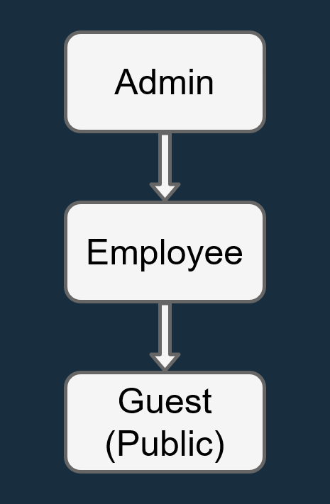

* Note: Some issues were not yet fixed thus I will be updating this in several upcoming weeks/months. And I hope that this project will be used for educational purposes and that the system itself maintains its copyrights as proposed.

Enjoy :)

**Concepts**

**Login**

**Guest is publicly available**

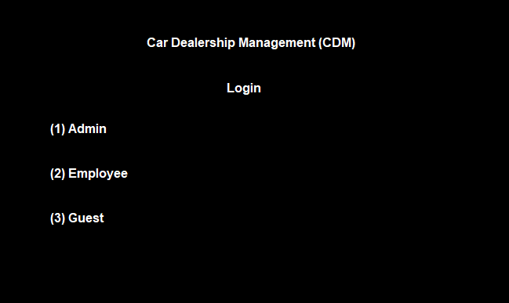

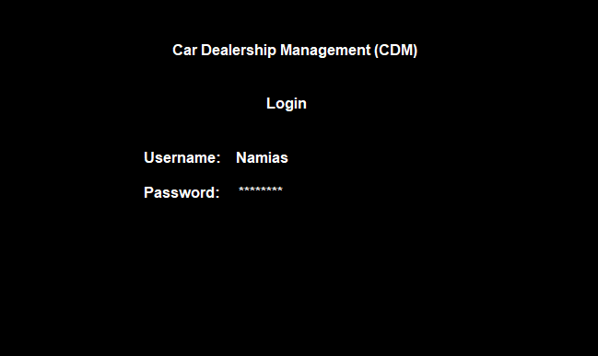

**Admin has a lot of privilege**

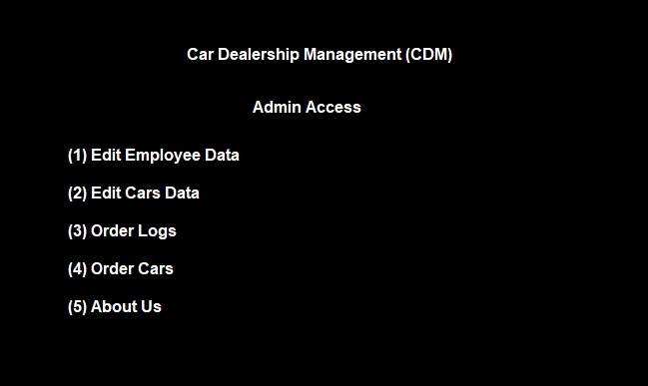

**Project Proposal in CCS 102 — Fundamentals of Programming**

**Project Title:** Fast Food Point of Sale

**Project Description:**

Fast food point of sale is a basic computer program that can take orders, compute total bill and changes of a customer. It can help the small-time business particular their cashier or sales management but this program is only built for a I customer at a time a mini program that can print/display receipt of a customer.

**Features:**

* 1. Can take orders from customer
  2. Can calculate the total bill of the customers
  3. Can display orders, total bill and exact change of customers
  4. Can display receipt of the customer

**Limitation**

1. Console application no GUI
2. Can only take I customer at a time
3. Can't show photos of a product
4. No database

Concerns

1. On 'Admin'>'Employee Data'>'Add Employee Data' - After typing a username, it doesn't proceed.

2. On 'Admin>'Employee Data'>'Search - when typed a wrong non-numerical data, it stucks on 'Sorry, You entered wrong choice. Kindly try again' prompt and can't go back.

3. On 'Admin>'Cars Data'>'Edit Cars Name & Price' - When selected, it leads to 'Ordering Cars'

4. On 'Admin>'Cars Data'>'Add Cars Color' - After Adding a color, it loops on 'Cars Data' Interface showing 'Wrong Input. Please Try Again. After Leaving the console and rerunning, it no longer works.

yan lang muna wait langg

4. Configured: Space ' ' is not allowed hence, Underscore should be used '_' when adding a two-word Color

Suggestion: Since space ' ' is not allowed, it is suggested to add some notes —that states that Underscore should be used instead of space— on the 'Add Color Page' to avoid confusion that leads to error.

5. On 'Admin'>'Cars Data'>'Delete Cars Color' - After inputting the number of line of color to be deleted, it doesn't proceed.

6. On 'Admin'>'Cars Data'>'Delete Cars Name & Price' - After inputting car's name & price number line, an error occured

*The console stopped working and can't be run again

7. On 'Employee' Log in Menu - After logging in with non-existent user, It stuck on red error screen

*Note nag-delete ako ng user para ma-test yung 'Delete Employee' feature, 'Miku' yung in-input kong username/Password

bali nung ni-log-in ko yung 'Miku' red error screen lumabas